The Success and Failure Factor of Gaming Company – A Case Study of Nintendo

1. Introduction

Gaming market is a huge market and still in growth. According to Newzoo[1], the market will grow from $91.8 billion in 2015 to $118.6 billion in 2019. I can roughly divide the market into two segments : portable and non-portable. The former includes handheld devices like GameBoy, Nintendo DS, and smartphone, the latter includes TV Console and PC. This industry is a mix of software and hardware, and a mix of content and console. Some companies, like SEGA and EA, specialize only in content development, while the other companies, like Microsoft, SONY, and Nintendo, develop both the console and content. Excluding the count of general purpose platforms like PC and smartphone, there are three main players in TV console: Microsoft Xbox, SONY Playstation, and Nintendo Wii series. In handheld, Nintendo is the single major player while SONY’s PSP and VITA keep about 25% of Nintendo’s 3DS in 2015[2].

To evaluate the success and failure factor of a gaming company, I select Nintendo as our research target for the following reasons : (1) Nintendo is a pure gaming company. Unlike SONY and Microsoft whose revenue mainly rely on the other business different from gaming, Nintendo’s revenue is 100% by gaming. (2) Nintendo owns both TV Console and handheld console. (3) Nintendo develops not only consoles but also content. (4) Nintendo is the most open company to publish its sales data on Internet.

1. Data

All of my data for research is from Internet :

1. Nintendo’s 36-year annual revenue[3] : Nintendo publicly shows its annual revenue in the period of 1981 to 2016. Unit : million Japanese yen.
2. Nintendo’s 19-year software and console annual quantity[3] : I also get annual shipment of console and content during 1997 to 2016. Unit : ten thousand ea.
3. Nintendo’s 38-quarter quarterly revenue[4] : From the Supplementary Information about Earnings Releases, I can get the numbers from Q2 2007 to Q3 2016, for the comparison with iPhone shipment. Unit : million Japanese yen.
4. iPhone’s 38-quarter quarterly shipment[5] : From Statista, I get the data since the announcement of iPhone in Q2 2007. Unit : million ea.
5. Xbox’s 38-quarter quarterly shipment[6] : Q2 2007 ~ Q3 2016. Unit : million ea.
6. Empirical Results

Figure 1 shows Nintendo’s 36-year sales data. With fiscal year ending at March, FY3/2009 means the year from Apr. 2008 to March 2009. One thing needs to be noticed is the company’s peak record happens at the worst timing of 2008 financial crisis. That raises a question : when many banks and companies bankrupted with many employees being laid off, why a gaming company reached its highest sales?

I assume that gaming, unlike food or housing, is not a basic need of human life. People can live well without gaming. People like to buy gaming console and content because they want to feel fun. At the worst timing of being laid off, their demand for gaming becomes high, and they have more time for gaming.

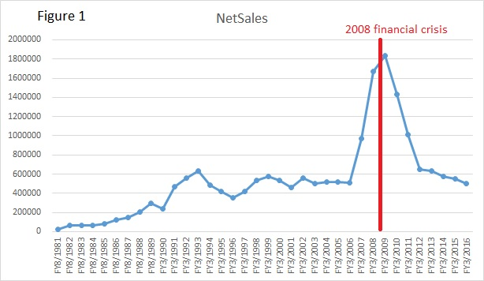

Figure 2 shows content quantity of both handheld and TV Console. These two consoles are totally independent, users can not use the gaming cartridge of handheld on TV console, and users can not use the DVD of TV Console on handheld devices. But these two sales reached the peak at the same time. That means users paid double price to buy both consoles and contents, and also says these two systems are not substitute of each other.

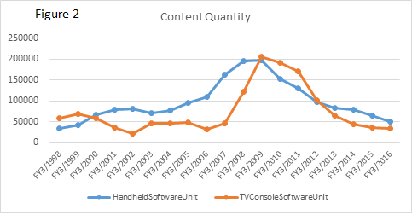

Can I regress Net Sales on content quantity? Unfortunately, these time series are not stationary[7]. By the command ur.df of library urca, with type =”drift” to test stationary, I find the tau values of 0 order, first order, and even 2nd order differences in Table 1. I find even 2nd order difference can not meet stationary for Net Sales at =5%.



However, if I use T=36 for Net Sales, then Net Sales will be I(1) at =5%.



I try to draw a correlogram for Net Sales even though it is non-stationary. Figure 3 shows the Net Sales series is correlated with recent 3 lags.

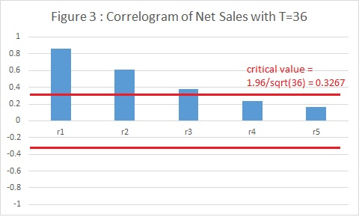

Here raises another question : if the economy condition of 2008 financial crisis could not negatively impact the gaming company’s net sales, what caused the company’s sales falling in recent 5 years, even though the economy was gradually recovered?

To answer this question, we need to think the basic nature of gaming business : people spend money on gaming because they want to feel fun. Furthermore, people buy some kind of content with console because they think that game will offer them unique fun. Here I emphasize ‘unique’ because that’s why Nintendo got a peak during 2006-2010. During that period, Nintendo’s Wii was the first and only TV Console offering body motion detection in game playing, and Nintendo’s DS was the first and only mobile gaming device with double screens and with a lot of casual gaming titles. Even though the CPU in Nintendo’s console was less powerful than competitor’s, Nintendo still defeated SONY and Microsoft.

In 2011, Nintendo launched 3DS which was an improvement of DS in handheld console. In 2012, Nintendo launched Wii U which was more powerful than Wii in TV Console. These two consoles can play all their precedents played. But Figure 1 and Figure 2 show the sales was bad.

Is the new console less fun? No. They can play all their precedents played so they should be more fun than the precedents. However, they are not unique fun any more. Apple launched iPhone since Q2 2007, in 2011 the accumulated base of iPhone was so huge that Nintendo’s handheld gaming business was seriously impacted. And iPhone is a good gaming device by which users can download tons of casual games or hardcore games at free or low price. In TV Console, Microsoft Xbox launched Kinect which can detect body motion even without any controllers held in user’s hands. This made Nintendo’s Wii and Wii U less attractive.

To test my assumption, I collect 38-quarter data since Q2 2007 when iPhone was launched. I also collect Xbox sales data and Nintendo’s sales data in the same period. Each company has its own fiscal year, e.g., Nintendo’s fiscal year ends at Q1 while Microsoft’s fiscal year ends at Q2 and Apple’s fiscal year ends at Q3. I have aligned each company’s quarterly sales data to the same calendar quarter to make a regression.

Before making a regression, I first check if these time series are stationary. These time series are displayed in Figure 4 (a)(b)(c). I decide to use type=”trend” in Nintendo Sales and iPhone, “drift” in Xbox. The unit-root result is listed in Table 3. I find all three time series are stationary!

The regression result is shown in Table 4. The Significance F = 7.363e-12, showing this model is valid. The p-value of each coefficient is e-10, showing the variables are significant. R-square = 77% says 77% of variation in Nintendo Sales can be explained by the variables. The equation is :



Nintendo Sales = 232273.9 - 6043.7\*iPhone + 61381.3\* Xbox

The unit of iPhone and Xbox is in million ea and the unit of Nintendo Sales is in million Japanese yen. I can interpret like this : when iPhone increases the sales unit by 1, Nintendo Sales will decrease by 6043.7 Japanese yen, that is about US$60.

The Xbox coefficient leaves us a question. When Xbox increases the sales unit by 1, Nintendo Sales will increase by 61381 yen? This result disobeys our assumption!



To explain the myth in Xbox coefficient, maybe I can refer to Figure 5 by Statista[2]. All of gaming consoles are declining since 2008. So Nintendo’s decline in Net Sales is not caused by Xbox, but caused by something else outside the gaming consoles, maybe something like iPhone which caused TV Console to decline. And I explain Xbox coefficient in the other way : when Xbox decreases the sales unit by 1, Nintendo Sales will decrease by 61381 yen.

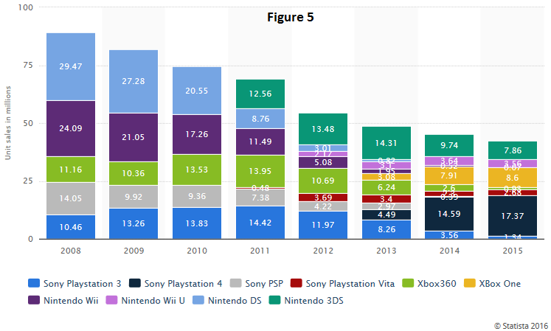

1. Conclusion

The analysis in this paper shows some interesting features of gaming business. First, the bad economy could not badly impact the gaming company while the good economy could not benefit it. Second, the gaming business was influenced more by substitute than by economy. Third, to offer fun, and unique fun, is the success factor of gaming business.

So what should a gaming company like Nintendo do? The global gaming market is still in growth while the gaming consoles are declining, the reason is the gaming industry is growing in other platforms like smartphone and tablet. So Nintendo gradually changes its strategy. Nintendo does not insist to play its content on its own console. This year, Nintendo announced to join Apple console so that users can download Super Mario and play it on iPhone and iPad. Also this year, Nintendo’s Pokemon Go, a location based free game on smartphone, created an overwhelming phenomenon around the world. This company is still trying some new and unique fun for customers. That is what gaming business means.

Notes

[1] <https://newzoo.com/insights/articles/global-games-market-reaches-99-6-billion-2016-mobile-generating-37/>

[2] <https://www.statista.com/statistics/276768/global-unit-sales-of-video-game-consoles/>

[3] <https://www.nintendo.co.jp/ir/en/library/historical_data/index.html>

[4] <https://www.nintendo.co.jp/ir/en/library/earnings/yearindex.html>

[5] <https://www.statista.com/statistics/263401/global-apple-iphone-sales-since-3rd-quarter-2007/>

[6] <https://barefigur.es/companies/microsoft/products/>

[7] The regression of Net Sales by HandheldSoftwareUnit and TVConsoleSoftwareUnit is as following. The model is valid and coefficients significant. However, because of non-stationarity and there is no cointegration between two variables, we can not adopt the regression.

